Stress test

In maintenance work, stress testing is an essential task. For example, before a website is launched, how much traffic it can afford and how well it performs in large traffic situations will directly affect the user experience. However, there is a commonality in the stress test; that is, the results of the stress test and the actual load results will not be the same. Even if the stress test work is done well, there is no guarantee that 100% and the online performance indicators are the same. Faced with these problems, we can only try to find ways to simulate. Therefore, stress testing is vital. With this data, we can be quite aware of our platform for maintenance. Webbench is a well-known website stress testing tool developed by Lionbridge Corporation (<http://www.lionbridge.com>).

We use webbench to complete our stress test. We simulate four situations as follow four figures. The results show that our ONEBOX could perform well in a stress situation.

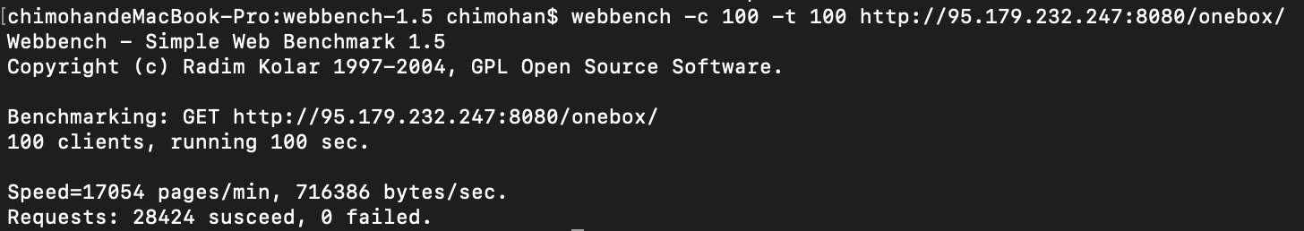

Figure 1: 100 clients, running 100 seconds

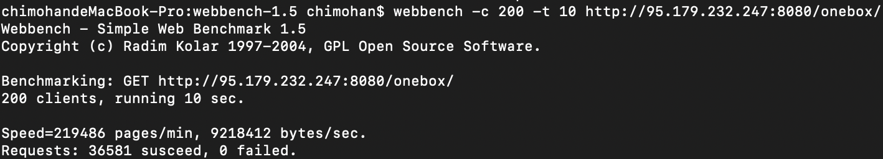

Figure 2: 200 clients, running 10 seconds

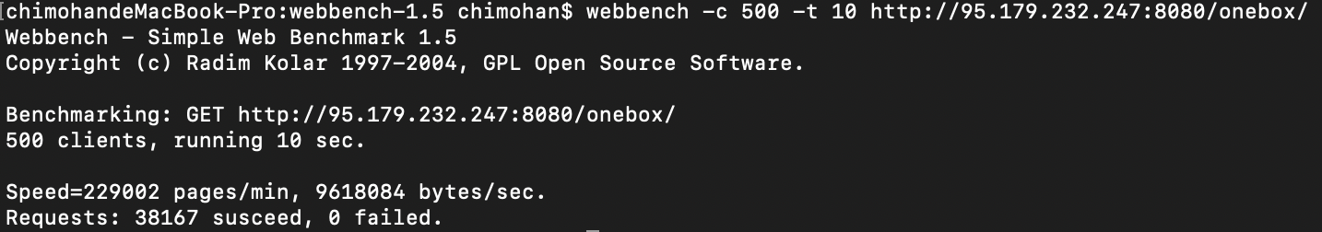

Figure 3: 500 clients, running 10 seconds

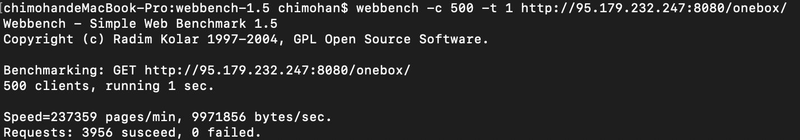

Figure 4: 500 clients, running 1 second